**Name : Shahzadi Begum Shaikh Rafique**

**Assignment : C Sharp 1st Assignment**

## 

1. Write a Simple console Application Calculator with the help of Visual Studio .NET IDE which will perform following operations on two numbers:
   1. Addition.
   2. Subtraction.
   3. Multiplication.
   4. Division

Accept input from user and display results on console. Make use of loops, switch case wherever required.

**Solution:**

using System;

class Calci

{

Static void Main(string[] args)

{

double num1, num2, result = 0;

Console.WriteLine("Enter first number:");

n1= Convert.ToDouble(Console.ReadLine());

Console.WriteLine("Enter second number:");

n2= Convert.ToDouble(Console.ReadLine());

Console.WriteLine("Enter an operator (+, -, *, /): ");

char operand = Console.ReadKey().KeyChar;

Console.WriteLine();

switch (operand)

case '+':

res = num1 + num2;

break;

case '-':

res = num1 - num2;

break;

case '*':

res = num1 * num2;

break;

case '/':

res = num1 / num2;

break;

default:

Console.WriteLine("You have entered wrong operator");

break;

}

Console.WriteLine(num1 + " " + operand + " " + num2 + ": " + result);

Console.ReadLine();

}

}

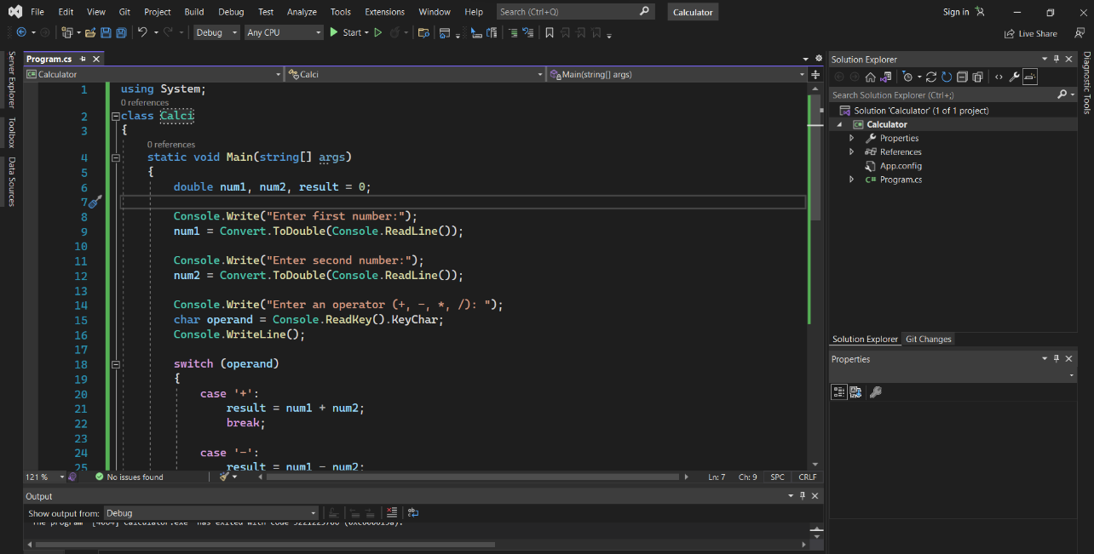

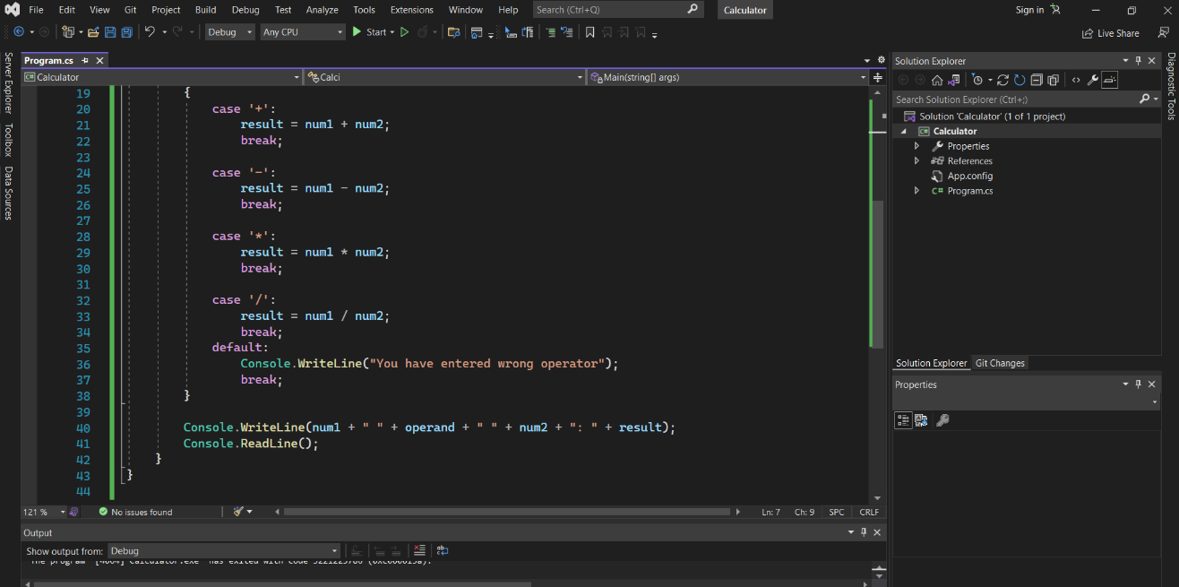

**OutPut**

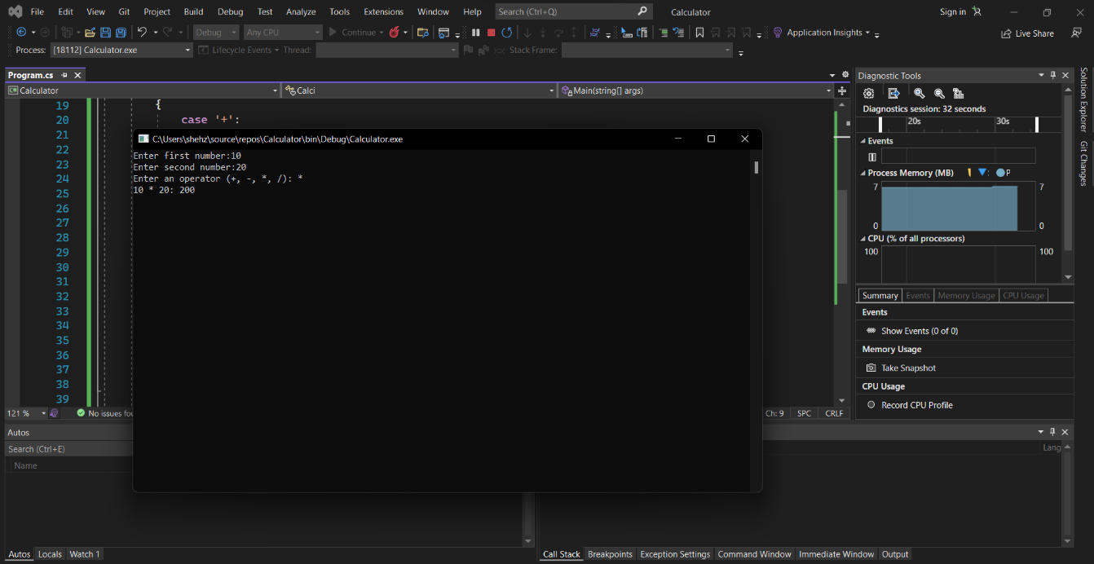

1. Accept average marks of five students. Display the highest marks obtained.

**Solution:**

using System;

using System.Collections.Generic;

using System.Text;

namespace highmarks

{

class Highest

{

Static void Main()

{

int m1,m2;

int max = 0;

int [] arr = new int[100];

Console.WriteLine("Enter No of Marks : ");

m1 = Convert.ToInt32(Console.ReadLine());

for(m2=0;m2<m1;m2++)

{

arr[m2] = Convert.ToInt32(Console.ReadLine());

If(arr[m2]>max)

{

max = arr[m2];

}

}

Console.WriteLine("The Highest Marks Is : {0} ",max);

Console.ReadKey();

}

}

}

Output

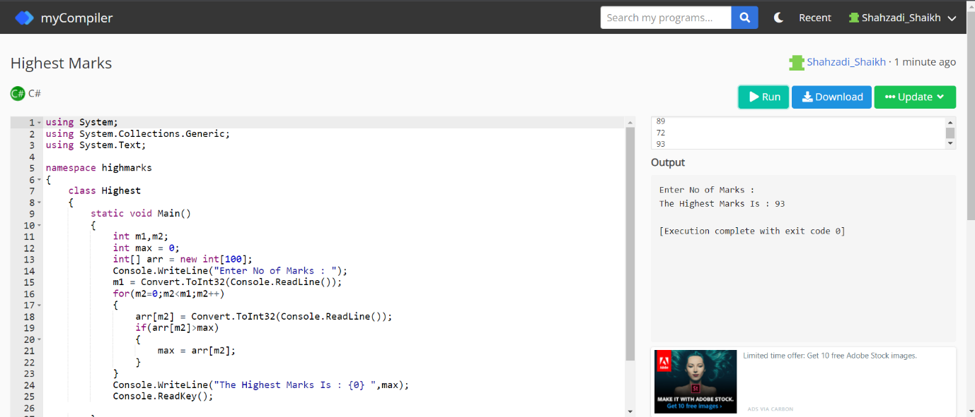

1. Write a static method to accept param array of integers. The method should find the sum of all the integers passed and display the result. Write a client program to call the method.

using System;

class param

{

static int sum(int []arr, int n)

{

int sum = 0;

for (int i = 0; i < n; i++)

sum += arr[i];

return sum;

}

public static void Main()

{

int []arr = {10,20,30,40};

int n = arr.Length;

Console.Write("Sum of given array is " + sum(arr, n));

}

}

**Output**

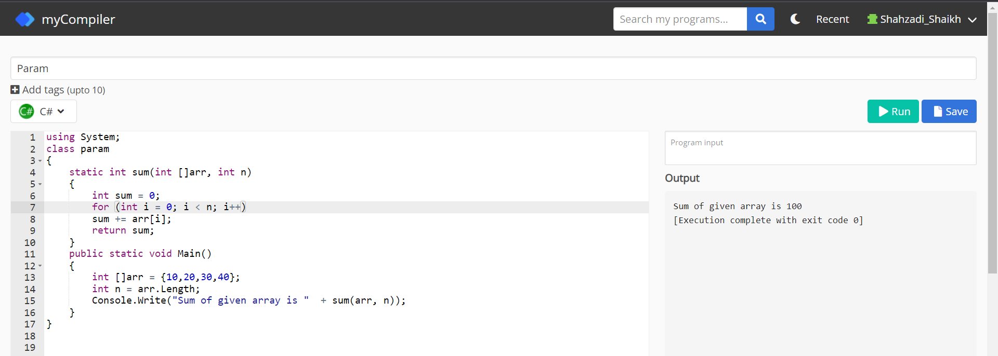

1. Write a method to swap two integers. The client code should call the method and print the swapped value.

**Solution**:

using System;

using System.Collections.Generic;

using System.Linq;

using System.Text;

using System.Threading.Tasks;

namespace Swap

{

class Swapval

{

public static void Main(String[] args)

{

int n1, n2, temp;

Console.WriteLine("Input the First Number : ");

n1 = int.Parse(Console.ReadLine());

Console.WriteLine("Input the Second Number : ");

n2 = int.Parse(Console.ReadLine());

temp = n1;

n1 = n2;

n2 = temp;

Console.WriteLine("After Swapping : ");

Console.WriteLine("First Number : " + n1);

Console.WriteLine("Second Number : " + n2);

Console.ReadKey();

}

}

}

Output

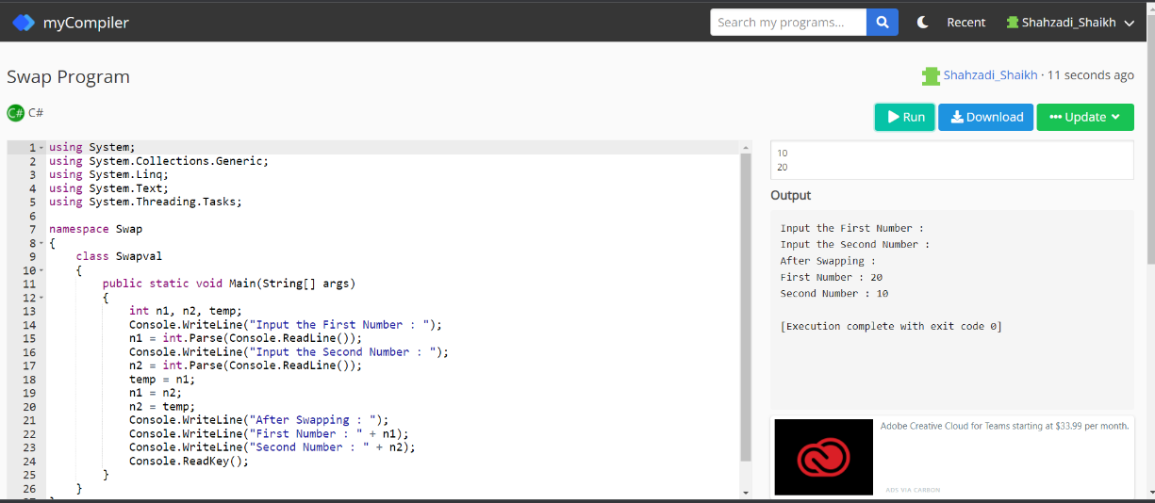

1. Write a single method that calculates the area and circumference of the circle. The area and circumference should be displayed through the client code

**Solution:**

using System;

using System.Collections.Generic;

using System.Linq;

using System.Text;

using System.Threading.Tasks;

namespace area

{

class circle

{

public static void Main(String[] args)

{

double Area,Circumference;

const double PI = 3.14;

Console.WriteLine("Enter the radius of circle ");

double r = Convert.ToDouble(Console.ReadLine());

Area= PI * r * r;

Circumference = 2 * PI * r;

Console.WriteLine("The area of circle is =" + Area);

Console.WriteLine("The circumference of circle is =" +Circumference);

Console.ReadKey();

}

}

}

**Output**

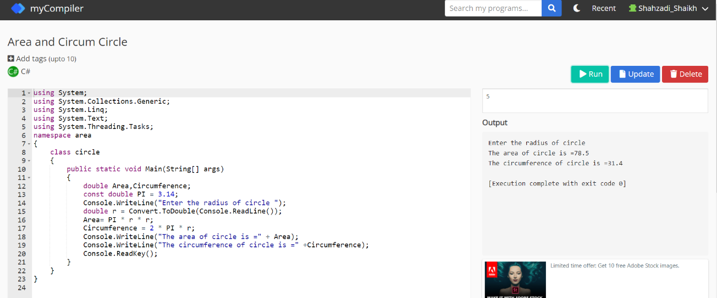

1. Create a structure Book which contains the following members: bookId, title, price, book Type.Type of the book should an enumerated data type with values as Magazine, Novel, Reference Book, Miscellaneous. Write a console based application to do the following tasks.
   1. Accept the details of the book
   2. Display the details of the book. The type of book should be displayed as a string e.g.:

Magazine

Note: Use methods for accepting and displaying details.

**Solution:**

using System;

using System.Collections.Generic;

using System.Linq;

using System.Text;

using System.Threading.Tasks;

namespace BookStructure

{

class Book

{

class strurucure

{

struct Books

{

private int bookId;

private string booktitle;

private string bookType;

private int bookprice;

public void getValues(string T, string t, int p, int id)

{

booktitle = T;

bookType = t;

bookprice = p;

bookId = id;

}

public void display()

{

Console.WriteLine("Title : {0}", booktitle);

Console.WriteLine("Author : {0}", bookType);

Console.WriteLine("Cost: {0}", bookprice);

Console.WriteLine("Book_id :{0}", bookId);

}

};

public static void Main(string[] args)

{

Books Book1 = new Books();

Books Book2 = new Books();

Book1.getValues("C#",

"Text Book", 500, 3296810);

Book2.getValues("DBMS",

"Booklet", 800, 6918345);

Book1.display();

Book2.display();

Console.ReadKey();

}

}

}

}

**Output**

